2020-2021 Program Review Report

Division/Area Name: A&H, Commercial Music | For Planning Years: 2022-2023
Name of person leading this review: Gary Heaton-Smith
Names of all participants in this review: Gary Heaton-Smith, Nate Dillon, Peggy Martindale, Jeffrey Bretz, Michael McCully

Part 1. Program Overview:

1.1.Briefly describe how the program contributes to the district mission
The AVC Commercial Music area is committed to student success by offering value (through world-class faculty in an equitable environment), opportunity (by offering a variety of applied, theoretical, and historical courses), and in service to the Antelope Valley community (by engaging with the community through performance).

1.2.State briefly program highlights and accomplishments
Despite decreasing enrollment, the MUSC program has maintained higher than average success (85.4%) and retention (92.5%) rates. The program has been bolstered immensely by the hiring of its first full-time faculty member (Nate Dillon) and additional specialized adjuncts. The program continues to engage with the campus by expanding program electives to include courses from FTV, ELEC, and WE. The program recently trained faculty for AVID software instruction, gaining licenses in Sibelius and ProTools. The training of our students on this software leads to industry-leading certification and is imbedded in the Studio Music Production course sequence and will be imbedded in MUSC 160B (beginning Fall 2022). Additionally, the Marching Arts Certificate has been revised and expanded into a Music Education certificate to help serve those students looking to pursue jobs in private and classified music education. Lastly, the program sequence is being reduced to one year for student access.

1.3. Check each Institutional Learning Outcome (ILO) supported by the program. Type an “X” if checkbox is unavailable.
☐X Communication | ☐X Demonstrates analytical reading and writing skills including research, quantitative and qualitative evaluation and synthesis.  ☐X Demonstrates listening and speaking skills that result in focused and coherent communications
☐X Creative, Critical, and  Analytical Thinking | ☐X Uses intellectual curiosity, judgment and analytical decision-making in the acquisition, integration and application of  knowledge and skills.  ☐X Solves problems utilizing technology, quantitative and qualitative information and mathematical concepts.
☐X Community/Global  Consciousness | X Understands and applies personal concepts of integrity, ethics, self-esteem, lifelong learning, while contributing to the well-  being of society and the environment.  X Demonstrates an awareness and respect of the values of diversity, complexity, aesthetics and varied cultural expressions.
X Career and Specialized  Knowledge | X Demonstrates knowledge, skills and abilities related to student educational goals, including career, transfer and personal  enrichment.
1.4. Check each Educational Master Plan (EMP)/Strategic Plan Goal supported by the program. Type an “X” if checkbox is unavailable.

X Goal 1: Commitment to strengthening institutional effectiveness measures and practices.

X Goal 2: Increase efficient and effective use of resources: Technology; Facilities; Human Resources; Business Services.

X Goal 3: Focus on utilizing proven instructional strategies that will foster transferable intellectual skills.

☐ Goal 4: Advance more students to college‐level coursework-Develop and implement effective placement tools.

X Goal 5: Align instructional programs to the skills identified by the labor market.

Part 2.A. Please provide the results of any internal and external environmental scan information you have gathered related to the program e.g. surveys, interviews, focus groups, advisory groups, licensure exam scores, job placement, State mandates, etc.:
An advisory committee meeting will occur in November 2021. Action items from the meeting are as follows:
-Apply for Perkins funding for audio new equipment and program development
-Addition and creation of MUSC 109 History of Motown course as an option for “History of...” component
-Add ELEC 110 as option for Commercial Music elective credit.
-Add Media Scoring course
-Revise Marching Arts Certificate to broaden into Music Education Certificate (including courses in Music Ed Foundations and Basic Arranging and Techniques)

-TOP 100500 Employment Projections are favorable for our unique program in the state of California
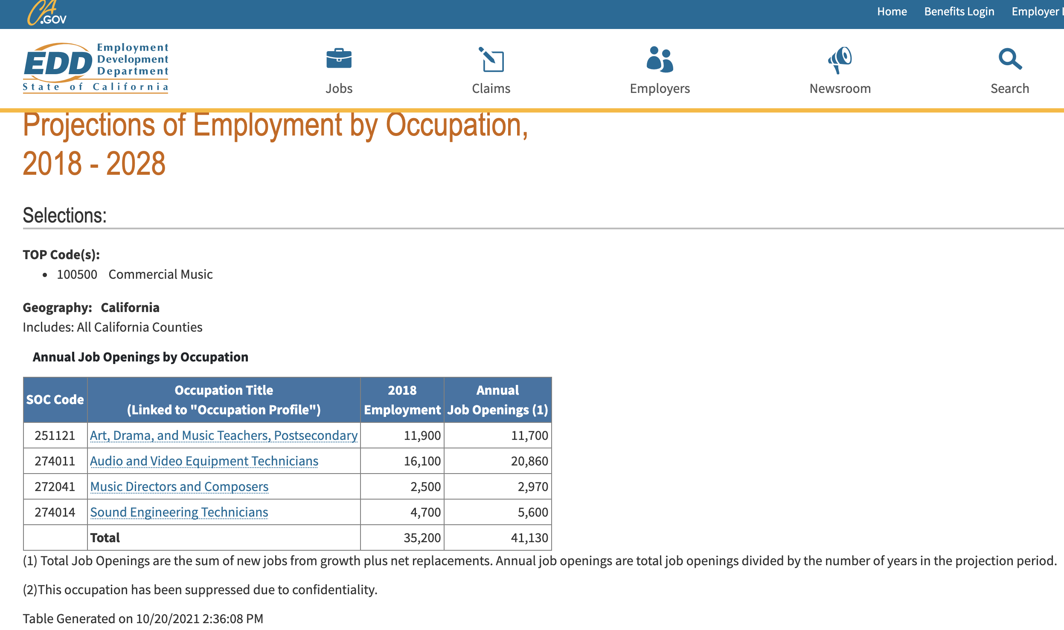

Part 2.B. Analyze the program review data (please see the program review data retrieval instructions and attach your program review data page with any other supporting documents), the above environmental scan information, and anything else related to your area to identify the program strengths, weaknesses, opportunities, & threats (SWOT):
Strengths | Retention and success rates are remarkably stable and above average
Weaknesses | Enrollment is down campus-wide.
Opportunities | Stable retention and success—despite depreciating enrollment and section numbers—allows the faculty to focus more intently on the core classes that have been offered. This has also directed the faculty to offer more electives outside of the MUSC program.
Threats | Low enrollment has caused many sections to be cancelled. Because we do not have a lot of sections of each course, that means many courses (primarily electives) are not being offered. Some of these courses impact the quality of others (e.g. Stage Voice > Commercial Music Ensemble) while some are “student life” courses and are challenging our ability to retain students (although its not shown in the numbers, e.g. Rock Band)
Part 2.C. Review and comment on progress towards SLO/PLO/OO Outcomes Analysis (fka Action Plans):
-Notation and sequencing software has been purchased/licensed and implemented into the curriculum (including new desks in the DA lab)
-A performance rubric is not complete, but all SLOs now align, allowing for the rubric to be created more easily.
-After further review, the MUSC 143 text is suitable, especially considering MUSC 133 sequence students will be using the ProTools manual (and both classes are required)

Part 2.D. Review and comment on progress towards past program review goals:
-The previous goal of maintaining 20 awarded degrees/certs was not accomplished. However, the department had many challenges in teaching Commercial Music during the COVID-19 closure. It is expected that enrollment—and therefore degree completion—will increase as instruction is stabilized.
-Increasing public exposure has been difficult during the closure. However, the Commercial Music ensemble recorded an album (remotely) with portions being released to the public through AVC Marketing. Remote clinics at high schools were also accomplished, although this outreach is thought to be a temporary solution while not allowed on campus. The program is having a high profile guest in Fall 2021 which is expected to increase exposure.

Part 3. Based on Part 2 above, please list program/area goals for 2021-2022:
Program/Area Goal # | Goal supports which ILO/PLO/SLO/OO? | Description of Goal | Steps to be taken to achieve goal?
#1 | ILO #4 | Increase degree/cert completion #s to 20 | -Increase communication with Arts & Humanities Counselor  -Continue annual advisory panel that students attend at the beginning of the year and invite guests  -Create an outreach protocol to reach area students who are in the college selection process  -Launch Music Education Cert  -Launch additional courses that attract more students, including a Media Scoring course.  -Continue to assess and eliminate roadblocks in the curriculum  -Increase access to modern learning tools (like documentaries on standard streaming services, Study.com, and other OERs) to increase student interest
#2 | ILO #2, #3, #4 Level I Cert PLO #2, #5 Level II Cert PLO #1, #2 AA Degree PLO #1, | Increase performance opportunities and public exposure for students as a form of outreach for the program. | -Participate in High school outreach opportunities in coordination with Student Activities and Outreach.  -Schedule more student performances on and off campus, in coordination with Student Services and outside business.

Part 4. Resource Requests that Support Program Needs (Based on above analyses and listed in priority order):
Type of Resource Request | Summary of Request |  | New or Repeat Request | Amount of Request, $ | One-Time or Recurring Cost, $ | Contact’s Name
Faculty
Classified Staff | Producer / Technical Director, for all Performing Arts events (Commercial Music Included) |  | Repeat | $20,000 | Recurring | Gary Heaton-Smith
Technology | Access to premium curriculum services (Study.com) and standard streaming services (Netflix, Hulu, etc) for documentary access |  | New | $1,000 | Recurring | Gary Heaton-Smith
Physical/Facilities
Supplies
Professional Development | Advisory Panel, Outreach |  | Repeat | FPD | Recurring | Gary Heaton-Smith
Other

**REQUIRED: After gathering the information above, fill out your RESOURCE REQUESTS to be shared with the Budget Committee: https://www.surveymonkey.com/r/20-21ProgramReview

Part 5. Insert your Program Review Data here, as well as any other supporting data. (See Part 2.B above.)

